Reviewer comments:

Reviewer #1 (Comments to the Author (Required)):

In this manuscript, Stephenson et al investigated the effects of in utero exposure to Environmentally Persistent Free Radicals (EPFR's) on growth, metabolism, energy homeostasis under the conditions of diet-induced obesity. One of the main conclusions of the report is gestational exposure to MCP230 results in a reduction in energy expenditure, partly through impaired mitochondrial metabolism in the skeletal muscle. This is an important paper and the work is performed to a high technical standard.

Comments:

The report did not show any signaling data to support alteration in skeletal muscle metabolism or growth. It will be helpful to include some Western blot on phospho-proteins which are regulated by insulin/ IGF1 (such as Akt and p70S6K).

**Response: We had measured Akt phosphorylation on Ser474, S6K phosphorylation on Thr389, and AMPK phosphorylatin on Thr172 via western blot. We felt that this data did not add any value to our manuscript, as there were no differences between the groups, thus chose not to include it in our original submission. This data is included here for your convenience; however, we still don’t think that its inclusion will add value to the revised submission.**

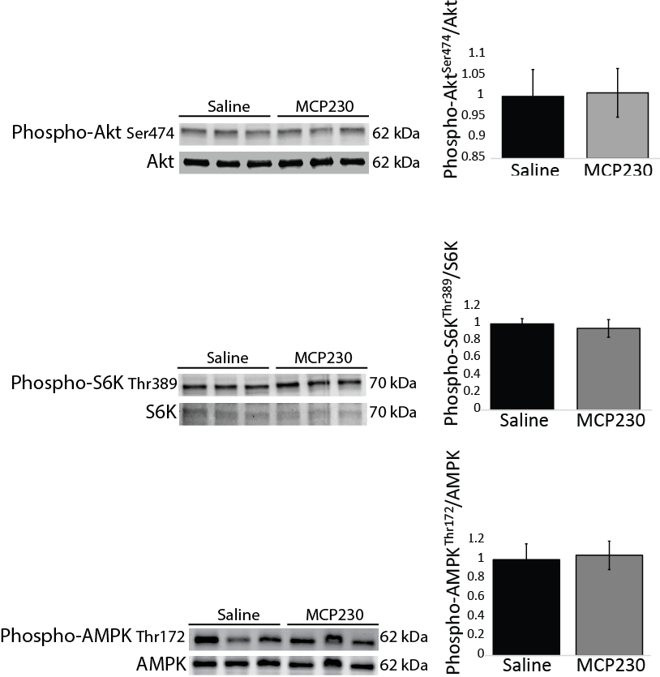

Does the alterations in "hunger hormones" alter the feeding pattern of mice in response to light-dark cycle? It will be interesting to include this data if it is available from the metabolic cage experiments. For example, did the mice eat more frequently (though cumulative food intake is unaltered)?

**This is an interesting thought, and we thank this reviewer for bringing it to our attention. We analyzed the feeding bout data from the metabolic cage experiments and found that the MCP230-exposed mice ate shorter, slightly smaller (but not significantly so in either case) meals. These changes primarily occurred during the light phase; however, these differences were not statistically significant. Even so, this finding could help explain the elevated ghrelin levels we observe in these mice. We have mentioned the altered feeding behavior in the revised manuscript. You can find this amendment in the results section on page XXXXX line XXXXX :**

**“**During the metabolic cage experiments the MCP230-exposed mice ate slightly less food per feeding bout (although this was not statistically different); whereas, each bout also tended to be shorter in duration (data not shown).”

Despite the profound changes in ghrelin and GLP1 levels, MCP230 mice did not display any alteration in glucose and insulin levels, and the fat mass appear to be mildly affected. The authors should provide an explanation for this in the discussion.

**Need to add to the discussion and then report back here**

The authors provided data which indicated impaired mitochondrial biogenesis. The authors should provide some data on the upstream regulators of mitochondrial biogenesis such as PGC1, PPAR or TFAM to strengthen the data.

**We thank this reviewer for this suggestion. We have analyzed the upstream regulators of mitochondrial biogenesis (*Ppard, Ppargc1a, Ppargc1b, Nrf1, Nfe2l2 and Tfam*) by qPCR and found that the MCP230-exposed group had similar mRNA levels to the control group for *Ppargc1a, Nrf1, Nfe2l2 and Tfam* (we have corroborated our finding that *Ppargc1a* was not different between groups with the finding that PGC-1α protein was also not different- see next comment). We did observe marked increases in *Ppard* and *Ppargc1b* in the MCP230-exposed mice, which is an interesting finding that may relate to our oxidative stress hypothesis. We have included this data as a new figure in our revised manuscript. This figure is also included here for your convenience.**

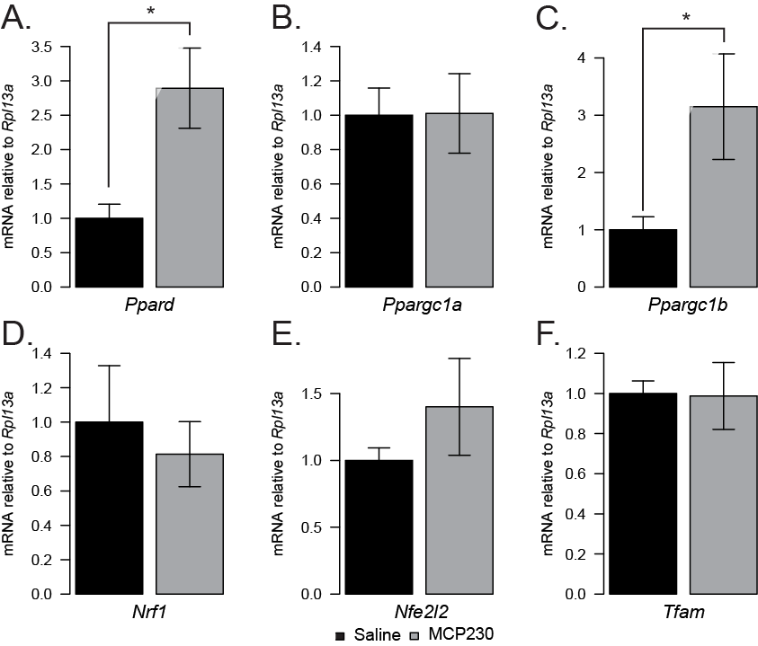

In Figure 5E, quantification of mitochondrial proteins revealed significant changes in NDUFB8 and ATP5A but the bands in the representative Western blot appeared unaltered (visually). Can the authors provide new analyses or blots which are more consistent? What is the significance that only NDUFB8 and ATP5A are elevated at protein level?

**We thank this reviewer for bringing this to our attention. After re-running the western blots for these same OXPHOS proteins (using a higher number of samples- 10/group) and PGC-1α, we found that there are no longer statistically significant differences between the groups for any of the proteins. We have amended the manuscript/figure accordingly. New representative blots and quantification are also included here for your convenience.**

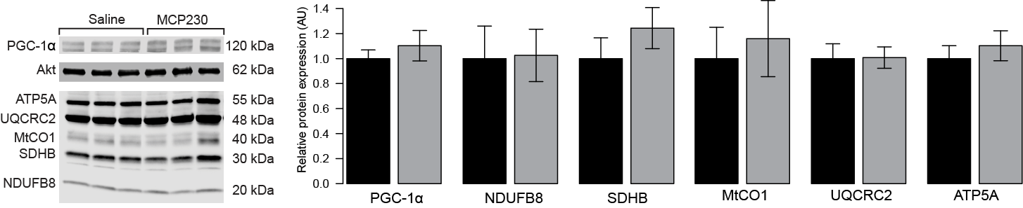

Reviewer #2 (Comments to the Author (Required)):

Stephenson and colleagues have shown that in utero exposure to environmentally persistent free radicals increases the adiposity of the offspring on chow, and on a high fat diet. Although these data are interesting, the dataset is missing important information and a number of major concerns exist.

Major

1) Functional measurements of insulin sensitivity are needed. A glucose tolerance test and insulin tolerance test would inform on whether the mice are metabolically compromised on the chow fed diet and high fat diet to match up with their increase in weight. Additionally, ex vivo measurements of muscle insulin-stimulated glucose uptake would inform on whether the increase adiposity alters skeletal muscle insulin sensitivity. Also - how long was the fast for Figure 3 data?

**We chose not to complete insulin or glucose tolerance tests on these mice as the different groups did not display different HOMA index values.**

2) It is unclear why the metabolic cage data is in chow fed mice while the mitochondrial experiments are in the HFD mice? It is currently inappropriate to try and explain the HFD mice skeletal muscle mitochondrial data with regards to the metabolic cage data. These seem to be completely different experimental groups and because of this, the proposed mechanisms are not supported by the data presented.

3) It is unclear why only VO2 is provided to explain energy expenditure. Please provide the Kcal data in addition to presenting the units in line 226-228. Also - considering energy expenditure is lower, analysis of uncoupling proteins in skeletal muscle and adipose depots may help inform on the mechanism.

4) Based on the RER data - it seems that the Cabosil control alters energy metabolism independent of the EPFR as the Cabosil group and the MCP230 group both show increases in fat oxidation (or decreases in carbohydrate oxidation) compared to saline. Thus, it is pertinent to ensure that the Cabosil is not a confounding variable. Also, why is the VO2 graph and the ambulatory movement graph labelled as both Saline and Cabosil while the RER is labelled as 3 groups? It is unclear what is happening here.

5) The fact that mitochondrial protein expression does not correlate with citrate synthase activity is interestingly and should be further addressed. Functional experiments in freshly isolated mitochondria or permeabilized myofibres would be important to investigate the functional significance of these differences.

Minor

Figure 3A y-axis is unusual

What is the dose of EPFR compared to how much a human would be exposed to?

Reviewer #3 (Comments to the Author (Required)):

This is a very interesting article in which the investigators propose that in utero exposure to particulate matter (EPFR) will increase the risk of the offspring developing a form of metabolic disease. The manuscript is very well written and the overall presentation is strong.

Although, the hypotheses are important the submission suffers from an incomplete assessment of mitochondria and lacks any attempt to provide a mechanism to explain the outcome. It is further challenging to determine if the effect of EPFR is a direct or a secondary effect on the skeletal muscle. Overall, the manuscript is largely dependent on mRNA and protein measures as a surrogate for functional measures, which significantly reduces the enthusiasm for the ideas that drive the submission.

No functional data provided for the mitochondria (i.e. mitochondrial respiration). When considering the defined hypotheses it would seem these measures are necessary.

In the same line of thinking, the discussion provides extended discussions on oxidative stress, yet the submission does not provide a single measure of oxidative stress.

Also, there is a disconnect between the mtDNA results and the results obtained using the OXPHOS antibody with no clear explanation over why this may have occurred. Functional data or EM imaging likely would clear this up.

Providing some sort of intervention that targets the skeletal muscle mitochondria to prevent the overall phenotype induced by the EPFR would significantly strengthen the study.

Finally, the purpose of the idea was to determine if the animals develop a form of metabolic disease after the EPFR exposure. Thus the authors provided the animals with a HFD, however based on the way the data are presented it is challenging to determine if the HFD actually had an effect. Specifically, there is no attempt to determine if the mice develop any sort of glucose intolerance or insulin intolerance while on the HFD.